APPENDIX 1

**FITNESS CLUB**

PROJECT REPORT

***by***

Alwin George

Joel George Philip

Mohd Saayem Siddiqui

(Section – koc03)

(Roll number 58,74,68)



**Department of Intelligent System-I**

**School of Computer Science Engineering**

**Lovely Professional University**

**Jalandhar, Punjab**

December 2022

**APPENDIX 2**

Student Declaration

This is to declare that this report has been written by me/us. No part of the report is copied from other sources. All information included from other sources have been duly acknowledged. I/We aver that if any part of the report is found to be copied, I/we are shall take full responsibility for it.



Joel George Philip

RKOC03B74



Mohd Saayem siddiqui

RKOC03B68



Alwin George

RKOC03B58

Place : Jalandhar , Punjab

Date : 03/12/2022

**APPENDIX 3**

TABLE OF CONTENTS

|  |  |  |
| --- | --- | --- |
| **S:NO** | **TITLE** | **PAGE NO** |
| 1. | Introduction | 5-6 |
| 2. | Objective of the project | 7 |
| 3. | Features of the project | 8 |
| 4. | Project Screenshots | 9-12 |
| 5. | Future Scope of Work | 13 |

**APPENDIX 4**

BONAFIDE CERTIFICATE

Certified that this report “ FITNESS CLUB” is the bonafide work of

“ ALWIN GEORGE , JOEL GEORGE PHILIP , MOH SAAYEM SIDDIQUI , ”

who carried out the project under my supervision.

**Bhupinder Singh**

Assistant Professor

ID: 28636

Department of

Intelligent system-I

Chapter 1

**Introduction:**

HTML is an acronym which stands for **Hyper Text Markup Language** which is used for creating web pages and web applications. Let's see what is meant by Hypertext Markup Language, and Web page.

**Hyper Text:** Hypertext simply means "Text within Text." A text has a link within it, is a hypertext. Whenever you click on a link which brings you to a new webpage, you have clicked on a hypertext. Hypertext is a way to link two or more web pages (HTML documents) with each other.

**Markup language:** A markup language is a computer language that is used to apply layout and formatting conventions to a text document. Markup language makes text more interactive and dynamic. It can turn text into images, tables, links, etc.

**Web Page:** A web page is a document which is commonly written in HTML and translated by a web browser. A web page can be identified by entering an URL. A Web page can be of the static or dynamic type. **With the help of HTML only, we can create static web pages**.

Hence, HTML is a markup language which is used for creating attractive web pages with the help of styling, and which looks in a nice format on a web browser. An HTML document is made of many HTML tags and each HTML tag contains different content

Features of HTML:

* It is easy to learn and easy to use.
* It is platform independent.
* Image, audio and video can be added to Webpage.
* Hypertext can be added to text.
* It is a markup language.

How Does CSS Work?

CSS uses a simple English based syntax with a set of rules that govern it. Like we’ve mentioned before, HTML was never intended to use style elements, only the markup of the page. It was created to merely describe the content. For example: **<p>This is a paragraph.</p>**.

But how do you style the paragraph? The CSS syntax structure is pretty simple. It has a selector and a declaration block. You select an element and then declare what you want to do with it. However, there are rules you have to remember. The structure rules are pretty simple.

The selector points to the HTML elements you want to style. The declaration block contains one or more declarations separated by semicolons. Each declaration includes a CSS property name and a value, separated by a colon. A CSS declaration always ends with a semicolon, and declaration blocks are surrounded by curly braces.

What does java script Means?

JavaScript is a cross-platform, object-oriented scripting language used to make webpages interactive (e.g., having complex animations, clickable buttons, popup menus, etc.). There are also more advanced server side versions of JavaScript such as Node.js, which allow you to add more functionality to a website than downloading files (such as real time collaboration between multiple computers). Inside a host environment (for example, a web browser), JavaScript can be connected to the objects of its environment to provide programmatic control over them.

JavaScript contains a standard library of objects, such as Array, Date, and Math, and a core set of language elements such as operators, control structures, and statements. Core JavaScript can be extended for a variety of purposes by supplementing it with additional objects, for example:

* Client-side JavaScript extends the core language by supplying objects to control a browser and its *Document Object Model* (DOM). For example, client-side extensions allow an application to place elements on an HTML form and respond to user events such as mouse clicks, form input, and page navigation.
* Server-side JavaScript extends the core language by supplying objects relevant to running JavaScript on a server. For example, server-side extensions allow an application to communicate with a database, provide continuity of information from one invocation to another of the application, or perform file manipulations on a server.

This means that in the browser, JavaScript can change the way the webpage (DOM) looks. And, likewise, Node.js JavaScript on the server can respond to custom requests sent by code executed in the browser.

How we can add JavaScript to HTML?

we can add JavaScript code in an HTML document by employing the dedicated HTML tag <script> that wraps around JavaScript code.

The <script> tag can be placed in the <head> section of your HTML or in the <body> section, depending on when you want the JavaScript to load.

Generally, JavaScript code can go inside of the document <head> section in order to keep them contained and out of the main content of your HTML document.

However, if your script needs to run at a certain point within a page’s layout — like when using document. Write to generate content — you should put it at the point where it should be called, usually within the <body> section

**Chapter 2**

**Objectives of the project**

The ultimate goal of BE FIT is to help make its members healthier. Some health clubs require that new members undergo a health assessment. You will be weighed and a staff member will measure your body fat composition. These tests should not replace a proper wellness examination from your doctor. You should also consult your doctor before joining a health club, particularly if you are new to exercise.

Most health clubs employ personal trainers. Keep in mind that they charge by the hour, and that this cost is separate from your basic health-club membership fees. But BE FIT ` give you a free session with a trainer when you join. Personal trainers help safely take your workouts to the next level.

1. Member Management

A key objective of fitness club systems is to simplify the entire member management process. The bloodline of any health club is a happy and sustained membership base. You can break the objective of member management into two categories: acquisition and retention. Gym management software should help you both market your business to new gym members and retain those you already have. Using gym software for member management will simplify all aspects of the process, such as check-ins, online registration, payments, and database management.

2. Gym Scheduling and Class Bookings

You should be able to easily schedule classes and manage all bookings and any other events you’re hosting. A gym management system should link class bookings to your client-facing app so that your members can manage their classes and book time slots with their favorite instructor both online and offline. When investing in gym software or upgrading your existing system, this is a non-negotiable feature that will add to your value offering. Over time, it increases your member retention and attracts more customers who expect flexibility and complete convenience.

The basic competition chosen in this study involves three types of programming HTML, CSS, and Javascript. The purpose of this study is to produce a learning system as a learning supplement for students ordered to increase student’s interest in learning. Modern gym management systems may exceed what you will actually need, which is why it’s essential to know your objectives before searching for the software you’ll choose. By having a clear picture of what you want and can achieve through gym management software, you can find the best solution for your needs that will benefit multiple areas of the business.

**Chapter 3**

Features of the project:

* Strong online presence

* Location and contact information

* Good security, hosting and privacy Features

* Mobile-friendly and intuitive user experience

1. Strong Online Presence :

The COVID-19 pandemic has forced many people to live a more digital way of working and living. From homeworking to digital fitness, the online world is key to moving forward. Being able to adapt and take advantage of new online opportunities is crucial to success.

2. Location and Contact Information :

Your website needs to include all of your business information. Whether you’re an online-only digital fitness platform or have multiple gym locations throughout the country, you need to include all our information. Often, when visitors are looking for our website, they are seeking important information. Make it as easy as possible to find our location and contact us.

3 . Good Security, Hosting, and Privacy Features

To convert visitors into paying customers, our website needs to ensure the safety of your users. Privacy and security are hot topics, and we need to make sure you look after your customer data.

4. Mobile-Friendly and Intuitive User Experience:

Poor web experience will deter visitors. After one bad experience, they are unlikely to come back again.This means that the user should understand how to use the website design without consciously thinking about it. A responsive design is part of the user experience.

**Chapter - 4**

PROJECT SCREENSHOTS

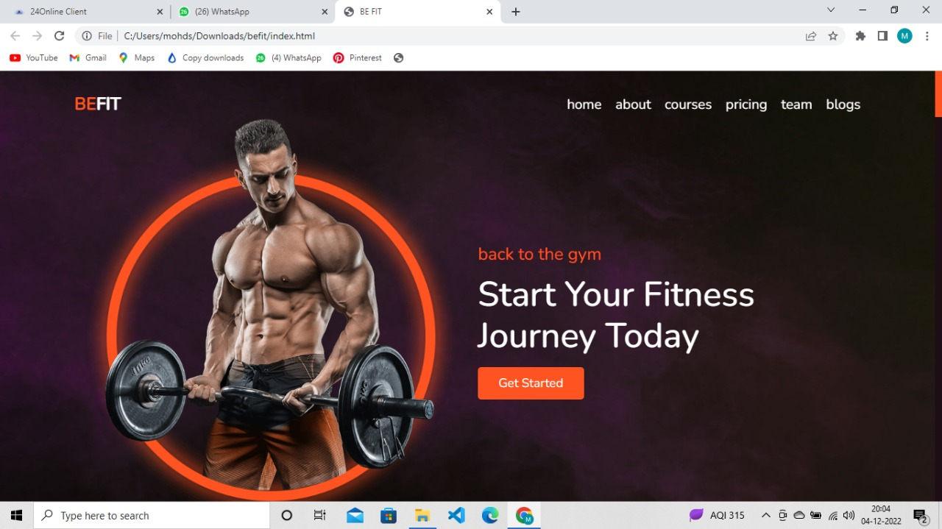

Figure 1. shows the home page

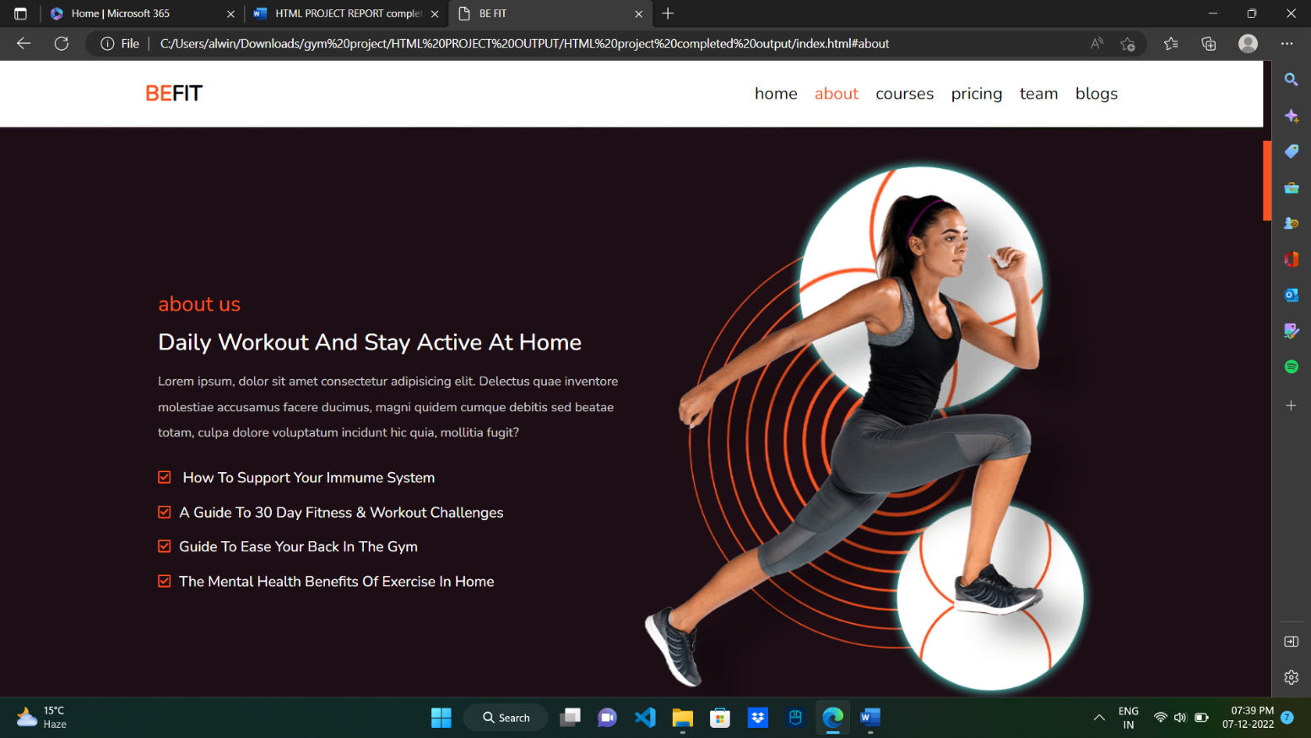

Figure 2. shows view of about as page

Figure 3. shows view of courses page

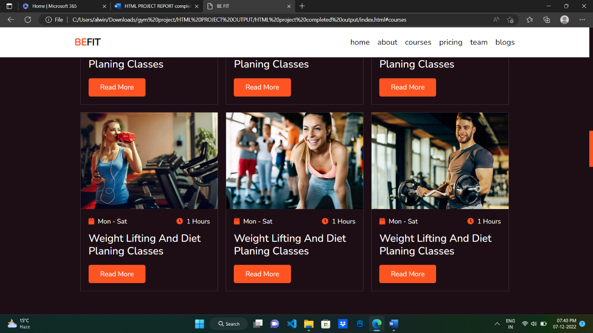Figure 4. shows another view of courses page

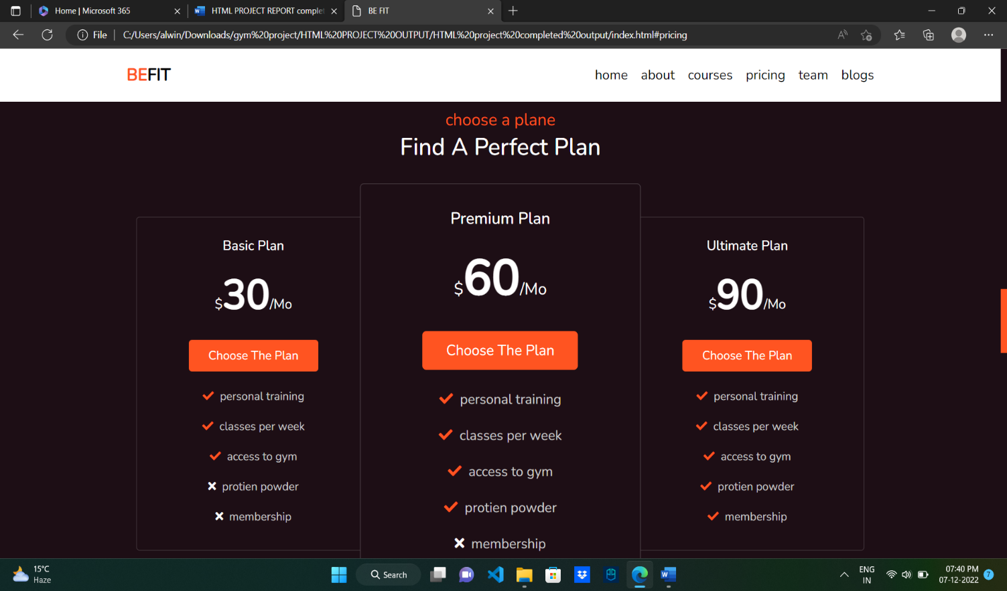

Figure 5. shows view of pricing page

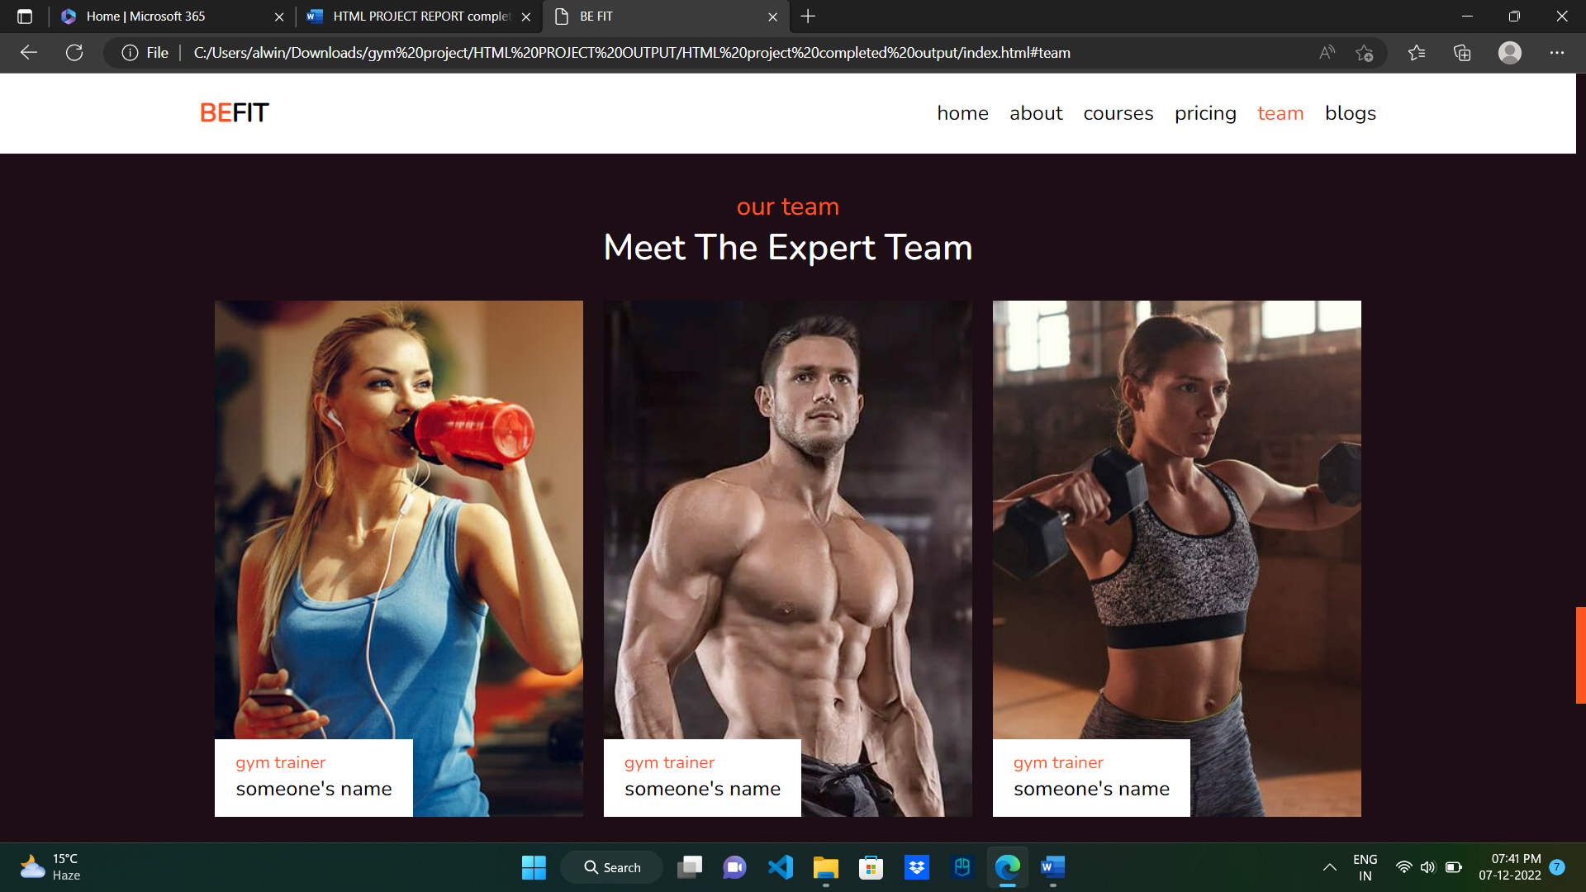

Figure 6. shows the view of team page

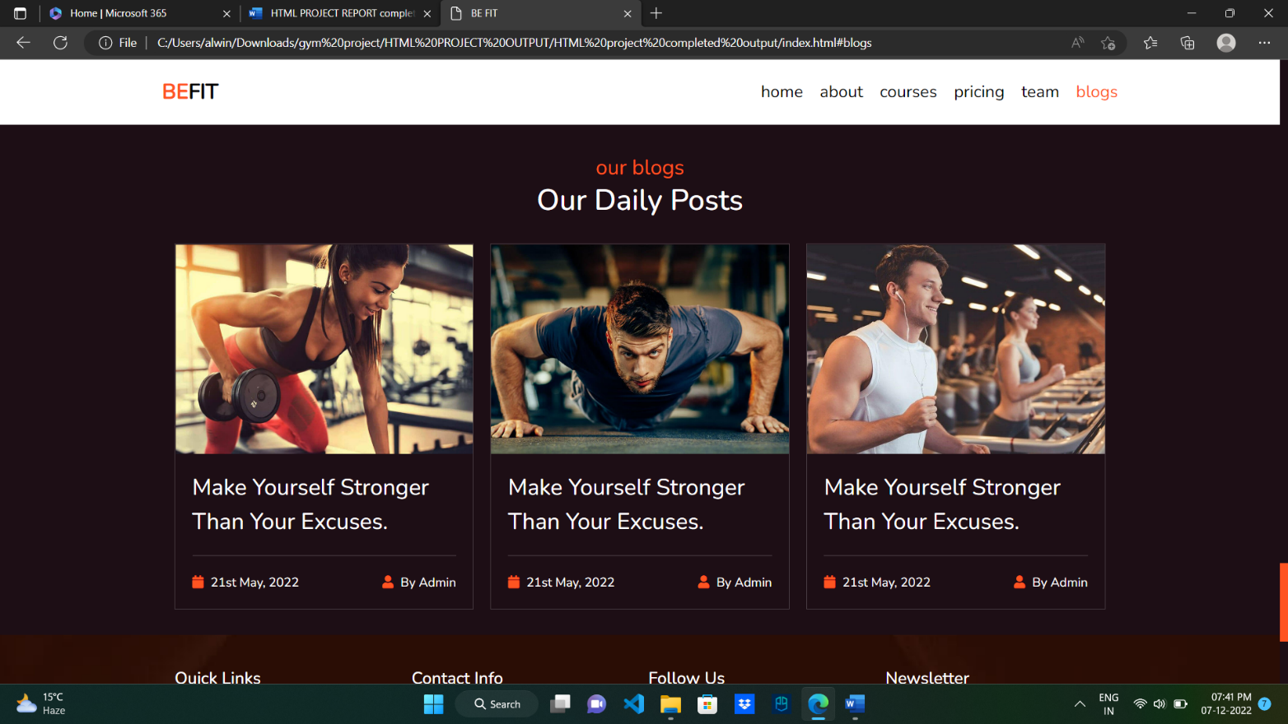

Figure 7. shows the view of blogs page

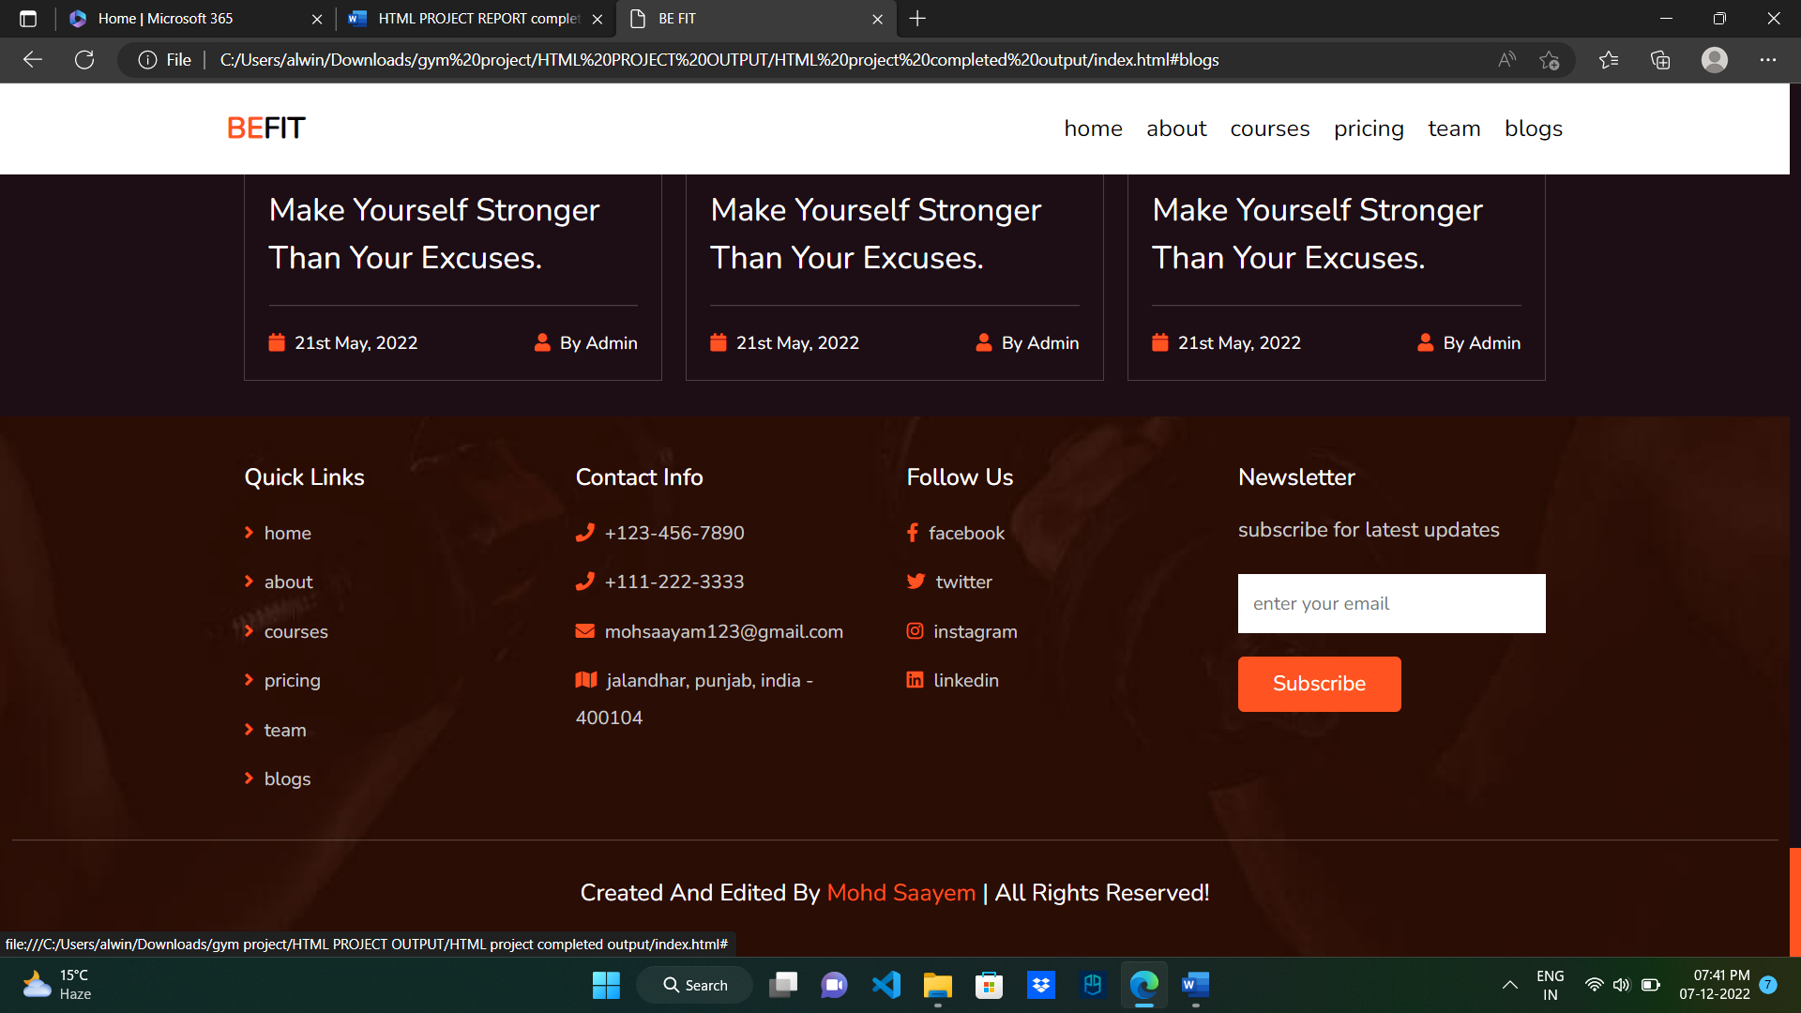

Figure 8. shows the view of bottom page

Chapter - 5

FUTURE SCOPE OF WORK **:**

BE FIT is meant to make running a fitness center easier. The program collects all data in one location, from online and schedule to automatic invoicing to administrative responsibilities, so you can operate your business more efficiently

It might be difficult to keep up with technologies advancements in a world where they happen so quickly. So, this is one the other hand, this may help fitness clubs to maximize their revenue potential. This type of software has evolved to provide more than just membership Payment processing and administrative functions. It may assist you managing al aspects of your business, as well as retaining and engaging members and most importantly, growing

BE FIT can help you to run your business more efficiently:

We can operate more productively if we can stream line our business this implies you waste less time and devote the proper recourses to ask. In the long term, using several tolls or manually doing administrative duties across multiple sites would reduce efficiency. More departments and teams are found in larger fitness clubs and their franchises.

When you have a steady flow on information, it can lengthen the time it takes to complete a task the simple line is that you can simplify project workflow and decrease time-consuming tasks regardless of how big or small your company is. This will save money in the long run.

Leasing, renting, or buying a gym facility is a tough financial decision and with the COVID-19 pandemic, even the well-established fitness clubs are struggling. The online streaming tools of a good fitness management system is set to change that.

The biggest advantage of having your streaming platform is the abilities of customization and adaptability. No longer are you restricted by specific geographic location of your business to reach and tap into a potential target group.

With an online platform can easily pre-record your classes and integrate them with our fitness website. These online fitness programs will help you reach a wider audience while keeping your operating costs comparatively negligible.